**RESTAURENT –APPLICATION**

A Thesis Submitted

in Partial Fulfillment of the Requirements

for the Degree of

**MASTER OF COMPUTER**

**APPLICATIONS**

in

**COMPUTER APPLICATIONS**

**By**

**Shivangi saxena**

**(Enrollment no. 190029014005178)**

**Under the Supervision of**

**Prof. Naresh Chandra**

**Kiet group of Institutions Ghaziabad**

**To**

**Dr. Vipin kumar**

**Faculty of Computer Applications**

## DR. APJ ABDUL KALAM TECHNICAL UNIVERSITY

### (Formerly Uttar Pradesh Technical University) LUCKNOW

**16 August 2021**



**DECLARATION**

I hereby declare that the work presented in this report entitled “RESTAURENT APPLICATION", was carried out by me. I have not submitted the matter embodied in this report for the award of any other degree or diploma of any other University or Institute.

I have given due credit to the original authors/sources for all the words, ideas, diagrams, graphics, computer programs, experiments, results, that are not my original contribution. I have used quotation marks to identify verbatim sentences and given credit to the original authors/sources.

I affirm that no portion of my work is plagiarized, and the experiments and results reported in the report are not manipulated. In the event of a complaint of plagiarism and the manipulation of the experiments and results, I shall be fully responsible and answerable.

Name:shivangi saxena

Enrollment no.: 190029014005178

Field : Computer Applications



**CERTIFICATE**

Certified that **SHIVANGI SAXENA (**enrollment no 190029014005178…..) has carried out the research work presented in this thesis entitled **“RESTAURENT APPLICATION”.**

for the award of **Master of Computer Application** from Dr. APJ Abdul Kalam Technical University, Lucknow under my supervision. The thesis embodies results of original work, and studies are carried out by the student herself and the contents of the thesis do not form the basis for the award of any other degree to the candidate or to anybody else from this or any other University/Institution.

(Prof. Naresh chandra) Prof. Siddheshwari dutt mishra)

(Computer applications

kiet group of institutions ghaziabad

Date:16/08/2021

**Table of content**

**Abstract…………………………………………5**

# Introduction………………………………………………….6

Motivation………………………………………………………7

# Background and Related Work……………………………….8

Product perspective…………………………………………………………………………………………….9

Why Angular……………………………………………………10

Why postman……………………………………………………14

Application model……………………………………………….15

Resto-application………………………………………………….16

Register…………………………………………………………….18

Login component…………………………………………………..19

Add component…………………………………………………..20

List component………………………………………………………..21

Update component………………………………………………………..22

Conclusion & future work………………………………………………….24

Bibliography…………………………………………………………………..27

Githublink………………………………………………………………………28

# Abstract

Restaurent application is a single page application designed in Angular primarily for use in the food delivery industry. This app will allow hotels and restaurants to increase scope of business by reducing the labor cost involved. The also allows to quickly and easily manage an online menu which customers can browse and use to place orders with just few clicks. Restaurant employees then use these orders through an easy to navigate for efficient processing.

This app is developed to automate day to day activity of a restaurant. Restaurant is a kind of business that serves people all over world with ready-made food. This system is developed to provide service facility to restaurant and also to the customer. This restaurant application can be used by employees in a restaurant to handle the clients, their orders and can help them easily find free tables or place orders.

# Introduction

It is known globally that, in today’s market, it is extremely difficult to start a new small-scale business and live-through the competition from the well-established and settled owners. In fast paced time of today, when everyone is squeezed for time, the majority of people are finicky when it comes to placing a food order. The customers of today are not only attracted because placing an order online is very convenient but also because they have visibility into the items offered, price and extremely simplified navigation for the order.

Restaurent Application that I am proposing here, greatly simplifies the ordering process for both the customer and the restaurant. Application presents an interactive and up-to-date restaurant with all available options in an easy to use manner. Once the order is placed it is entered in the database and retrieved in pretty much real time. This allows Restaurant Employees to quickly go through the orders as they are received and process all orders efficiently and effectively with minimal delays and confusion.

###### Motivation

The motivation for designing this application came because my family is involved in the fast food business and I personally do not like waiting for long in the store or to have to call store to place an order especially during the peak lunch or dinner hours. Moreover, I value recent learning about the Angular and Typescript Programming languages as well as seeing how powerful and dynamic they are when it comes to web designing and applications. The languages used to build this application are typescript, Bootstrap, HTML,CSS, Angular and client facing whereas Oracle database at the back-end because I found them to be extremely useful while working on the technologies.

# Background and Related Work

This Case study looks at the problem of setting up a fast food restaurant. In existing system there are few problems:

* For placing any orders customers have to visit hotels or restaurants to know about food items and then place order and pay. In this method time and manual work is required.

.

* Every restaurant needs certain employees to take the order over phone or in-person, to offer a rich dining experience and process the payment. In today’s market, labor rates are increasing day by day making it difficult to find employees when needed.

Hence, to solve this issue, what I propose is an “restaurant application”, originally designed for small scale business like College Cafeterias, Fast Food restaurant or Take-Out,.

The main advantage of my system is that it greatly simplifies the ordering process for both the customer and the restaurant and also greatly lightens the load on the restaurant’s end, as the entire process of taking orders is automated.

###### Product Perspective:

The Restaurant application is a web-based system. It can be accessed using simply

Why Angular?

We have witnessed tremendous changes and major developments in every sector for the last few years, and technology, with its own speed, has been able to overcome hurdles by bringing in new technologies, methods, and perspectives to solve problems. To specifically point on, Web Development has seen the rise of new methods to make stuff easy, fast, and better responsive, and for the same reason, Angular came into existence.

In 2010, Google introduced Angular, and the web development community wholeheartedly welcomed it, and as of the current situation, Angular has been highly used and recommended for web development.

# ****What is Angular, and Why do we need it:****

Agular’s CLI is easy to set up, use and comprises simple commands. Used to initialize, develop and maintain applications in Angular through the terminal. With a large number of engineers working on Angular CLI, updates are released for betterment. Angular (https://angular.io/) is an Open Source JavaScript Framework based on TypeScript, Developed by Google for web development. With growing popularity and demand for Single Page Applications, Angular was picked up quickly and adapted.

Things changed when “JS” was dropped from the name, making it Angular from 2016, for all further releases. Though Angular is now widely used, updates for AngularJS are still being released.

The answer to Why we need Angular is as simple as asking for a web development framework that is easy to learn and understand, offers swift compilation, has a wide range of tutorials, documentation, and support for newcomers. Since its initial release, the Angular framework has been under continuous development, and every new release has various new features along with previous issues resolved.

Along with such amazing benefits of choosing Angular, it is being supported by the Google Team, which itself is another great benefit. The easy addition of third-party tools and components makes it more interesting and easy to use.

A command-line interface is an important part, and An

Now that we know what exactly the Angular framework is and where it works better let us dive into the boon and bone of this amazing framework.

## ****Pros and Cons of Angular****

Every technology that comes to life has its advantages and disadvantages. Similarly, Angular has its own. These points define the place of any technologies in the whole system. Below are the points that show how and where Angular rocks and where it doesn’t:

## ****Component-Based****

The whole architecture of Angular, which is component-based, is one of the most important factors that separate Angular from others. Providing code of higher quality in a proper hierarchy with components as sections with respective functionality.

## ****Testing Friendly****

Having an application comprised of components as elements come with another advantage of being able to test Units separately in an efficient method.

Now, taking the same component-based advantage ahead brings another benefit: the ability to maintain easily. Having various elements makes it easy for teams to edit and make new needful changes without disturbing the whole application.

Other than these advantages, Angular brings in all that is good in TypeScript, RxJS library, etc. With its Hierarchy dependency injection, applications have better performance. Having an active ecosystem with tools, packages, plugins, IDEs, Angular universal, etc., makes it easier to solve any problem and not be stuck. Angular elements and directives are added advantages that can be implemented as per needs.

Along with such amazing advantages, Angular has a massive community of engineers. Since the inception, these communities have provided a wide range of tutorials, documentation, and productive discussions.

**Tediousness** is one of the complaints that come infrequently and has been since the start. Writing multiple lines of code for a single component. There’s a lot to be learned about Angular before actual implementation. Angular is not a single whole package, it comes with various other tools, and it is essential to learn others.

Having talked about benefits, it is essential to learn and understand where Angular lacks what. Now, we know that Angular was AngularJS at first, and both are still in use. So when the requirement is to shift from AngularJS to Angular, it takes time. Though there are ways to do it, Lazy Loading is the better option, as it begins loading only the required components of the previous application.

**Moving on, it is no big deal knowing how many frameworks and tools are involved in web development. But very few have had enough popularity and support, among which are Angular, React & Vue. In the next section, we will learn and compare these three.**

# why Bootstrap ?

**Bootstrap** is the most popular **CSS Framework** for developing responsive and mobile-first websites

* Time-Saving.
* Easy to Use.
* Responsive Grid System.
* Customizable.
* Cross-Browser Compatibility.
* Establish Consistency
* Open-Source.
* Huge Number of Resources and Community Support.

# 

Why Postman?

Postman is a great tool when trying to dissect RESTful APIs made by others or test ones you have made yourself. It offers a sleek user interface with which to make HTML requests, without the hassle of writing a bunch of code just to test an API's functionality.

Let’s say I wanted to make a GET request against a fan-made API for the video game Hearthstone to search for cards with “archer” in their name. If I wanted to test a GET request against this route without using Postman—instead actually writing out code in something like Flask—I would have to write out a whole new route and function to perform the request, then I would have to specify with more code what I want the response to look like, and finally I would have to print out the response to the console or provide some other way of actually viewing the response. Granted, I would probably need to write all this out anyway to make a functioning app using this API, but doing all this to simply test an API's functionality is unnecessarily tedious and time consuming when something like Postman exists.

With Postman, such a test is much more streamlined. All I have to do is plug the route into the address bar, select the GET response method on the dropdown box to its left, punch in my API key in the “Headers” section, specify that I want the response in “pretty” JSON format, and hit send. Then, I get the response data in easy-to-read JSON with a status code of 200, confirming the GET request was successful. It’s that simple!

###### Application Model:

The structure of the system have 6 main logical components:

* Resto application- It is the home page, here one can see the interface of application.
* Register: - This component allows to register first if someone is new user.

login-this component provide registered customer/ supplier to login.

* Add: This component allows u to add information details about user.
* List: this component will show all restaurants available and allows one to order from one’s favourite one.
* Update: This allows to update the information provided by user. On clicking this component it will redirect to add component form by this one cate update information.

Resto Application

* It is the home page, here one can see the interface of application.

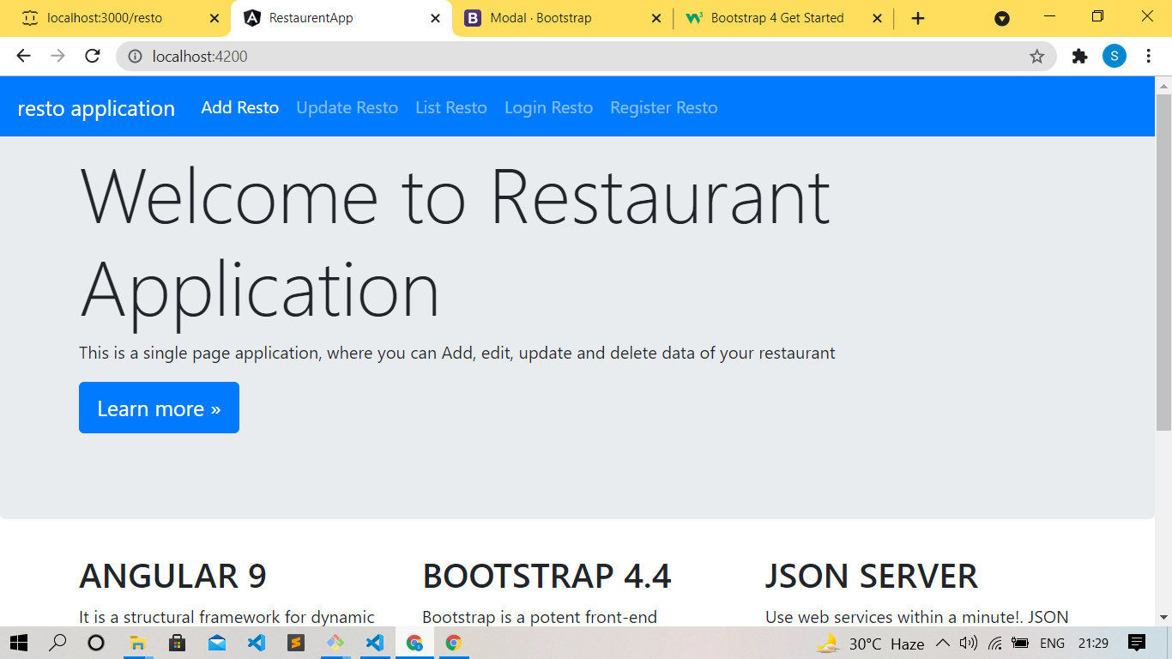

Fig:- 1.

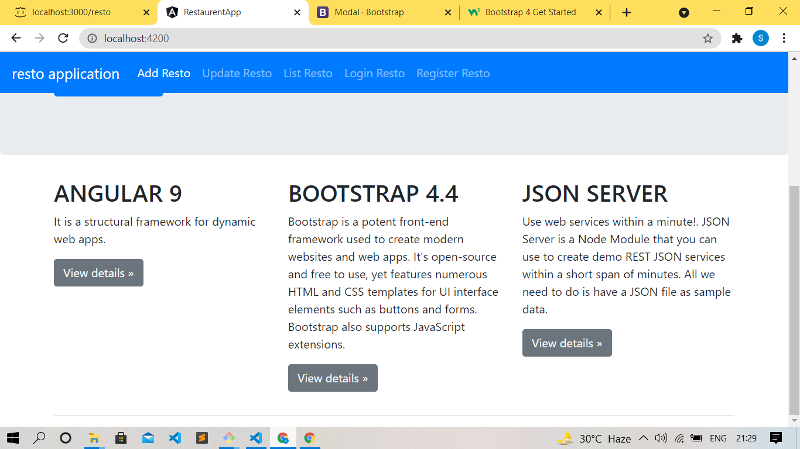

**Fig -2**

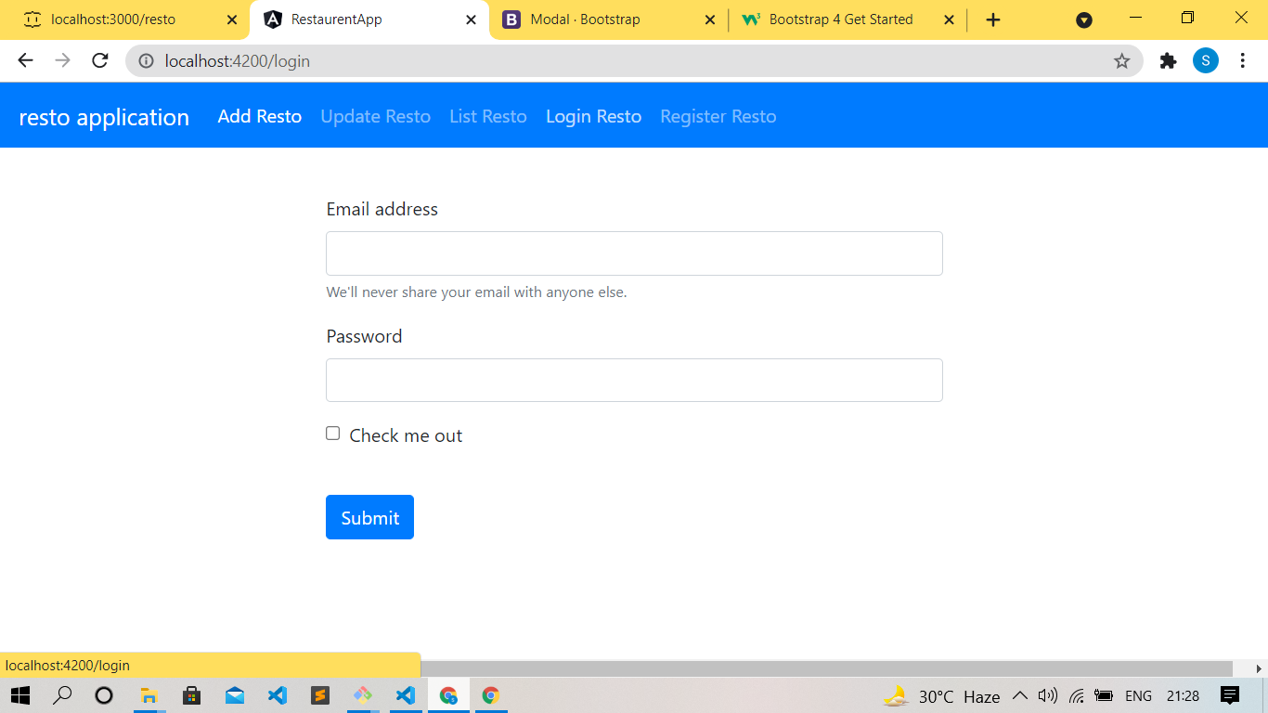

**Fig -3**

**Register**

* This component allows new user to regin when they visit firstly.

**Login component**

This allows registered user to login

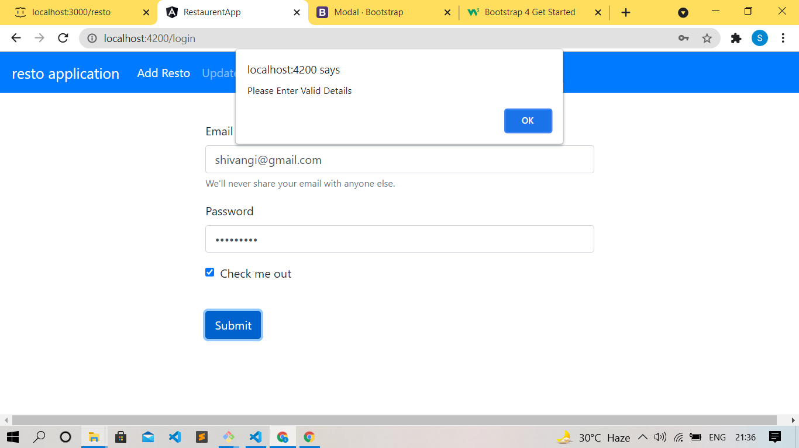

Fig-4

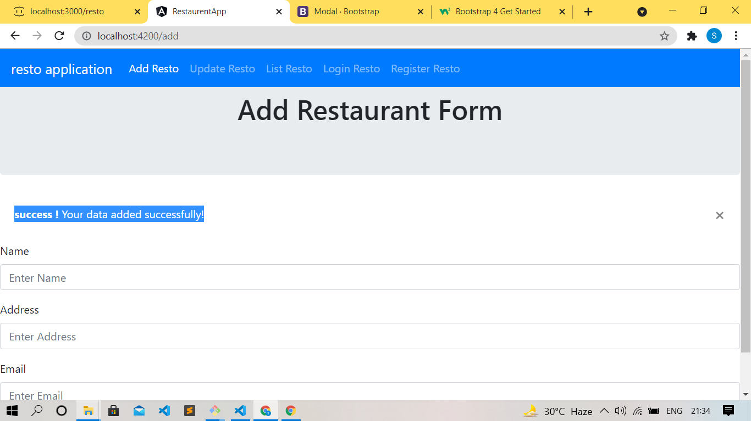

Fig -5

**ADD Component**

This allows user to add information .

List component

This component will list all information.

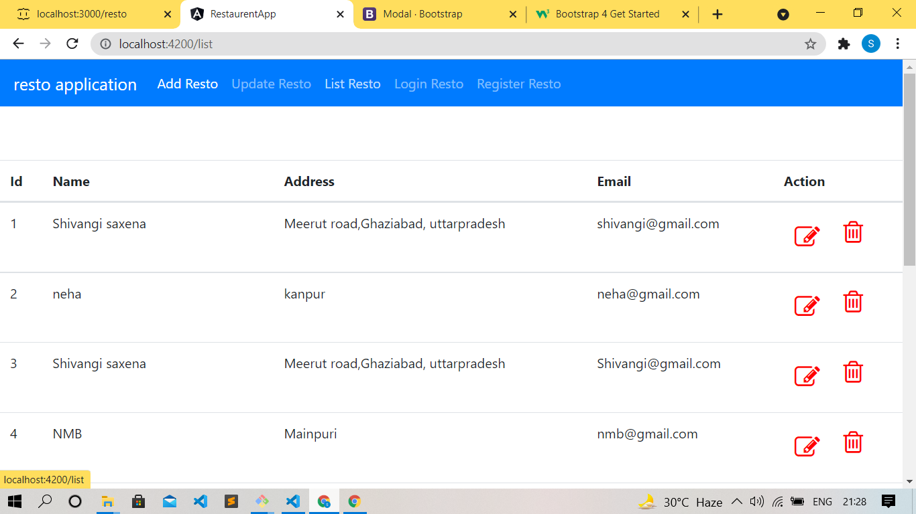

Update component

This component will edit the information and transfer to add component.



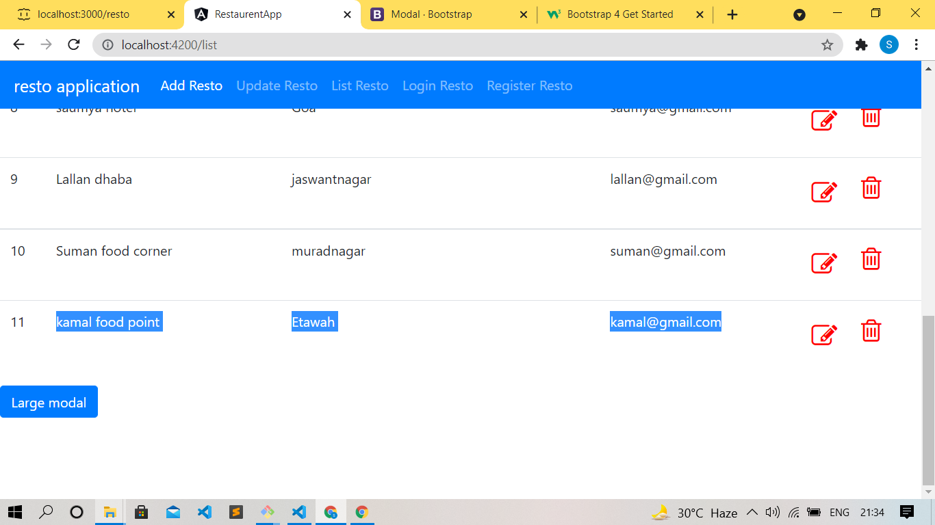

# Conclusions and Future Work

###### Conclusion:

The main objective of the application is to help Computer Science students understands the basics of css, JavaScript and HTML. The following results have been achieved after completing the system and relate back to the system’s objective.

###### Should allow Computer Science students to browse through the code and application:

This can be achieved when students are able to run and install the application. When they run the application, they can browse through the implementation of different objects.

* **Should allow users to browse through different product categories:** This is achieved through an easy to use graphical interface menu options.
* **Should allow users to save items to the cart and view detailed information about the order:** The users can add any number of items to the cart from any of the available food categories by simply clicking the Add to Cart button for each item. Once item is added to the cart, user is presented with detailed order to review or continue shopping.
* **Should allow the user to CheckOut the item(s):** This is achieved using the “Proceed to checkout button” in the cart initially and then “CheckOut” button at last step after “review Order” step.. Button is disabled when there are no items in the cart.
* **Should allow the user to process the payment:** This is achieved when user selects “Processed to Checkout” button and fill up the Payment information details.
* **Should allow the user to see Success message after placing an order:** This is achieved when user successfully places an order. The user is given the order conformation number along with success message.

###### Future Work:

The following section describes the work that will be implemented with future releases of the software.

* Customize orders: Allow customers to customize food orders
* Enhance User Interface by adding more user interactive features. Provide Deals and promotional Offer details to home page. Provide Recipes of the Week/Day to Home Page
* Payment Options: Add different payment options such as PayPal, Cash, Gift Cards etc. Allow to save payment details for future use.
* Allow to process an order as a Guest
* Delivery Options: Add delivery option
* Order Process Estimate: Provide customer a visual graphical order status bar
* Order Status: Show only Active orders to Restaurant Employees.
* Order Ready notification: Send an Order Ready notification to the customer
* Restaurant Locator: Allow to find and choose a nearby restaurant
* Integrate with In store touch screen devices like iPad

# Bibliography

<http://getbootstrap.com/>

<http://youtube.com>

<https://angular.io>

**Git hub link**

**https://github.com/0009shivangi/resto-app.git**

**Git hub link**

**https://github.com/0009shivangi/resto-app.git**

**Git hub link**

**https://github.com/0009shivangi/resto-app.git**